DNA Sequence Classification Using Compression-Based Induction
David Loewenstern, Haym Hirsh, Peter Yianilos and Michiel Noordewier
DIMACS* Technical Report 95-04 April 1995
*DIMACS is a cooperative project of Rutgers University, Princeton University, AT&T Bell Laboratories and Bellcore.
Abstract
The common DNA sequence identification models depend on the absolute locations. This paper describes a new class of learning methods called compression-based induction (CBI), which use text compression techniques as central idea.
- Introduction
The drawbacks of using models depend on locations: Nucleotides are regarded as independent attribute, lack of ordering and repetitions of subsequences features.
CBI can conquer these problems.
- Description of Algorithms
Zdiff: Training examples: S+ and S- were used to generate two separate models. These models were then applied to each test example t, yield two compressed sequence with length I(t | S+) and I(t | S-). If I(t | S+) < I(t | S-) t was classified into S+ (most likely concept)
Basic-cbi: Encoding each char in t by A,T,C,G and a pointer (n,i,l), the limitation of basic-cbi that substring is encoded by pointer if the length of a pointer is less than l(log₂5). Full-cbi forces every char to be encoded by a pointer, even if sequence becomes larger.
Tryeach: Examines each set S of training examples as being composed of n separate sequences labeled s₁ through s_{n}. Overall compressed length of t calculated as I(t | S) = 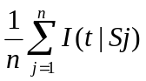.
Tryeach-hamming: Allows compression with lossy technique. It uses triple of the form (i,l,h) where h stands for hamming distance.
- Experiment Design and Results
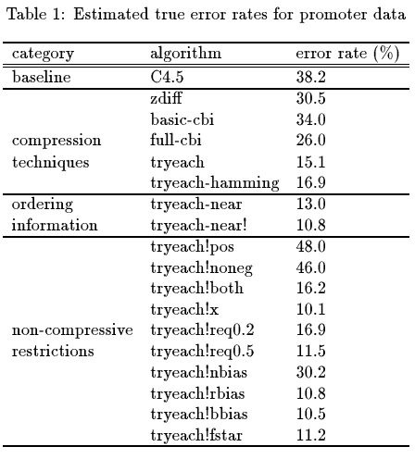
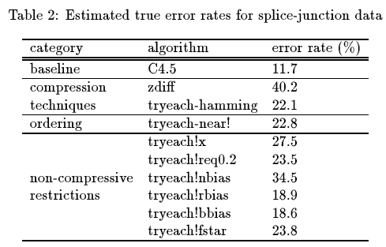

- Conclusion

Created by: Chia-Ling Sun
Date: Jan. 28, 2004

